High School Management System
Ifti Haque (210201020), Md. Nihad Hossain (210201023), Md. Nur A Alam (210201044) and Rakib Hasan Fahim (210201045)
Course Code: CSE 2206 Course Title: Database Management systems Sessional
Semester: Winter 2023
Department of Computer Science and Engineering, Bangladesh Army University of Science and Technology (BAUST)

- Introduction
1.1 Background
Education system forms the backbone of every nation. And hence it is important to provide a strong educational foundation to the young generation to ensure the development of open-minded global citizens securing the future for everyone. Advanced technology available today can play a crucial role in streamlining education-related processes to promote solidarity among students, teachers, parents, and the school staff.

Education is central to development. It is one of the most powerful instruments for reducing poverty and inequality and lays a foundation for sustained economic growth. With this aim currently, our government has given special emphasis to the educational sector and high school improvement activities such as continuous professional development for teachers, training, and upgrading teachers and capacitating schools with manpower and materials are among the major actions which have been taken in both primary and secondary schools. In order to facilitate and simplify these actions one of the major tools is to have an automated high school management system.

High School Management System (HSMS) consists of tasks such as registering students, attendance record keeping to control absentees, producing report cards, producing official transcripts, preparing timetables, and producing different reports for teachers, parents, officials from kebele or kefle ketema education bureaus, and other stakeholders.

Automation is the utilization of technology to replace human with a machine that can perform more quickly and more continuously [2]. By automating HSMS, documents that took up many large storage rooms can be stored on a few disks. Transcript images can be annotated. It reduces the time to retrieve old transcripts from hours to seconds. However, the school system in the government high schools of Addis Ababa is not automated, and the record officers generate transcripts and reports manually, and the school administrators use their experienced knowledge of miss and hit approaches to prepare timetables.

1.2 Societal and Environmental Impacts
Positive Societal and Environmental Impacts:
- Increased administrative efficiency and productivity.
- Enhanced data accessibility and transparency.
- Reduced paper usage through digitization.
- Improved learning experience and educational resources.

Negative Societal and Environmental Impacts:
- Digital divide and accessibility challenges.
- Overreliance on technology.
- Generation of e-waste.

Energy dependency and associated environmental concerns.
To maximize benefits and minimize drawbacks, strong data security, accessibility, and responsible technology use are crucial. Mitigating negative impacts includes responsible e-waste disposal and energy-efficient practices.

1.3 Objectives
- To build a responsive website to manage the different school activities.
- To track student’s grades from their parents.
- To facilitate distribution process of courses and classes for teachers.
- To facilitate grades entry process for students by teachers.
- To make a virtual community between the members of educational process.

- Problem Definition
To help promote students achievement and success, schools must have access to complete, accurate, and timely information about students. One of the benefits of automated HSMS is that the student record system will simplify retrieval of required information and is a great instrument for school improvement by taking measures from the information acquired. Despite the use of automated HSMS, the government schools in Addis Ababa are using paper-based documentation system for performing various tasks, and the school administrators apply their knowledge of hit and miss approach in scheduling classes and courses (preparing the timetable) which wastes manpower and much time unnecessarily that does not utilize the current technology.

Transcripts of students are prepared manually by the record officer and teachers. Report cards are produced by the home-room teachers. Attendance of students is recorded by the home-room teachers. In order to control absentees and know the number of days that a student has been absent from the school during the school days, the attendance officer has to collect the attendance slips from the corresponding homeroom teachers and compile it, which is also a time-taking process. In addition to that, retrieving records of students who have graduated a couple of years ago has been a difficult task, and the manual system also has difficulty producing different reports required by stakeholders such as teachers, administrators, or officials from kebele and kifle-ketema.

Teachers may want to associate a student with his parent or emergency persons for disciplinary measures which need searching of the students record in the record office. It has been difficult to search a record from thousands of such records and observed that students can take any person claiming that he/she is their parent or emergency person which creates a problem in control of students.

Due to the inefficiency of the current manual system, the need arises to automate HSMS in order to efficiently handle students’ attendance, to produce transcript, report cards, and the various reports satisfying users and customers, and to produce a timetable which can schedule courses for teachers and classes of students.

- Available Applications
Features:
Fekara: Fekara offers a comprehensive set of features, including a robust internal messaging system that facilitates seamless communication within educational institutions. It also provides user management tools to streamline administrative tasks, enhancing efficiency.
Limitations:
Fekara: Fekara has limitations, including limited storage capacity, which may pose challenges for schools with extensive data. It operates as a paid software, potentially affecting budget-conscious users.
Features:
Fedena: Fedena stands out for its user-friendly and customizable interface, making it easy for schools to adapt to their specific needs. The online learning module enables virtual learning, and its affordability allows for tailoring to specific requirements.
Limitations:
Fedena: Fedena's limitations include the registration process, which may be cumbersome for some users, and the fact that it is a paid software, limiting options for those seeking free alternatives.

Features:
Ascend SMS: Ascend SMS offers unique features such as discipline reporting, better communication between parents and educators, and efficient SMS-based student information management. These features enhance overall administrative efficiency and parent-teacher collaboration.
Limitations:
Ascend SMS: Ascend SMS restricts the number of schools that can use the system, potentially limiting its accessibility for larger educational networks. Additionally, it is only available for free to Catholic institutions, which may be a drawback for non-Catholic schools or organizations with budget constraints.

Features:
SchoolTool: SchoolTool provides notable features like attendance tracking, dedicated portals for parents and teachers, and it's available as free software. This enhances student attendance management and communication between schools, educators, and parents.
Limitations:
SchoolTool: Users may have concerns about data security, as open-source software like SchoolTool can be vulnerable if not properly configured and maintained. The user interface and feature set may not be as user-friendly or extensive as some paid alternatives. Additionally, it may not be as scalable for very large or complex educational institutions.

Features:
Classe365: Classe365 includes instant SMS notifications, robust finance and billing tools, and a comprehensive gradebook and assessment system. These features improve communication, streamline financial processes, and facilitate efficient student performance tracking.
Limitations:
Classe365: Classe365's limitations include a potentially steep learning curve for new users, limited integration options with other software systems, affecting seamless workflow. Furthermore, its functionality may depend on internet connectivity, which can be a drawback in areas with unreliable internet access.

- Stakeholders
1. School Administrators:
- Oversee the entire school operation.
- Require tools for managing staff, students, and resources efficiently.
- Need access to comprehensive reports and analytics for decision-making.

2. Teachers and Educators:
- Manage class schedules, curriculum, and student progress.
- Need a platform for posting assignments, grading, and communication.
- Require access to student data to tailor teaching methods to individual needs.

3. Accountants:
- Handle financial aspects including fee collection, payroll, and budget management.
- Need a system for tracking expenses, generating invoices, and managing accounts.
- Require accurate financial reports for auditing and financial planning.

4. Students:
- Access personal schedules, grades, and assignments.
- Interact with teachers, submit assignments, and track academic progress.
- Use the system to register for classes and access learning materials.

5. Guardians:
- Monitor their child's attendance, academic performance, and behavior.
- Receive notifications about important events, assignments, and school announcements.
- Need a platform for communicating with teachers and staying involved in their child’s education.

In your high school management system project, it's crucial to design features that cater to the specific needs of each stakeholder group, ensuring seamless communication, efficient management, and a positive educational experience for all involved parties.

- Issues Encountered
1. Learning Period (HTML, PHP, CSS):
- Complexity of Technologies: Learning HTML, PHP, and CSS involves understanding different languages and their interactions. Each language has its syntax, rules, and best practices. Understanding the intricacies of these technologies can be challenging, especially for beginners.
- Dynamic Nature: Web technologies, especially PHP and CSS, are dynamic and often require real-time updates and adjustments. Keeping up with the evolving standards and techniques can be overwhelming, leading to a steep learning curve.
- Compatibility Issues: Ensuring compatibility across various web browsers and devices adds another layer of complexity. Code that works perfectly in one browser might display or function differently in another, necessitating thorough testing and debugging.

2. Data Collection:
- Data Accuracy: Collecting accurate and relevant data is crucial. Incomplete or incorrect data can lead to flawed analysis and decision-making. Ensuring data accuracy while collecting information from various sources can be challenging.
- Data Security: Protecting sensitive data from unauthorized access, breaches, or cyber-attacks is a paramount concern. Implementing robust security measures, encryption, and access controls to safeguard collected data is a significant challenge.
- Data Integration: Often, data comes from diverse sources and in different formats. Integrating this data into a unified format for analysis can be complex. Ensuring seamless integration without loss of vital information is a persistent challenge.

3. Database Design:
- Normalization: Designing a normalized database structure to eliminate redundancy and improve data integrity is essential. Normalizing databases without overcomplicating the design requires a deep understanding of the data and the business requirements.
- Scalability: The database design needs to be scalable to handle an increasing volume of data over time. Planning for future growth without compromising current performance is a delicate balance.
- Optimization: Optimizing database queries and ensuring efficient data retrieval is crucial for the system's performance. Poorly optimized queries can lead to slow response times, impacting the user experience. It requires constant monitoring and refinement of the database structure and queries.

Addressing these challenges requires a combination of in-depth knowledge, continuous learning, and practical experience. Collaborating with experienced professionals and staying updated with the latest developments in technology can help mitigate these issues effectively.

- System Architecture
Figure Flow Diagram For HSMS
Water
Fall
Model
Requirement Analysis
And Specification
Design Phase
Implementation
And Unit Testing
Integration And
System Testing
Operation And
Maintenance Fees
- Database Design

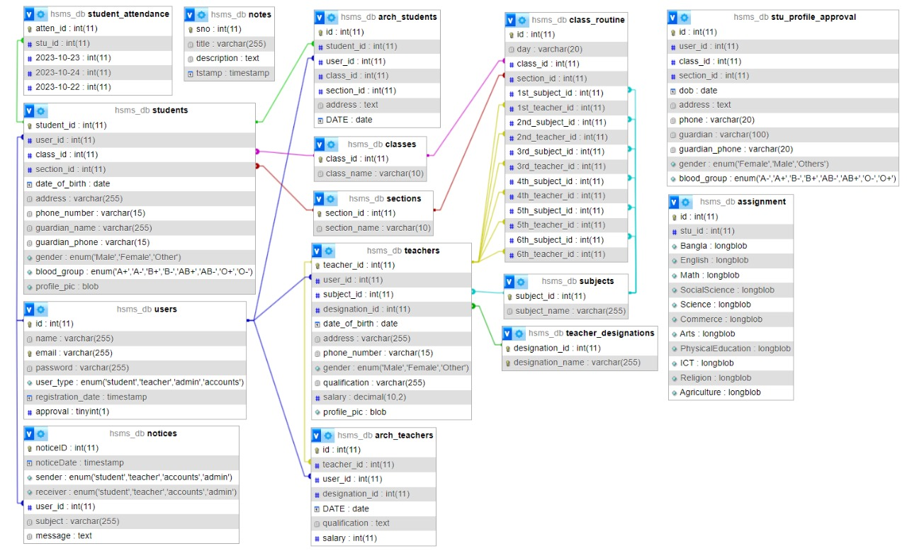
Figure 1 ER Diagram For HSMS

- Tools and Technologies

Programming Languages:
1. PHP:
- PHP is a server-side scripting language used for web development.
- It's versatile and can generate dynamic page content, handle forms, create cookies, and manage databases.
- PHP is widely used for building web applications and is compatible with various databases, making it a popular choice for web developers.

2. HTML (HyperText Markup Language):
- HTML is the standard markup language used to create web pages.
- It defines the structure of web content using elements like headings, paragraphs, links, and multimedia items.
- HTML provides the basic building blocks for web development and is essential for creating the layout and content of web pages.

3. CSS (Cascading Style Sheets):
- CSS controls the visual presentation of web pages, including layout, colors, and fonts.
- It separates the structure and content (HTML) from the presentation, allowing developers to create attractive and responsive designs for websites and web applications.

4. JavaScript:
- JavaScript is a versatile scripting language used for creating dynamic content and interactivity on web pages.
- It enables features like form validation, animations, and asynchronous data loading, enhancing user experience.
- JavaScript is essential for creating interactive web applications and adding behavior to websites.

Database Management System:

1. MySQL:
- MySQL is a popular open-source relational database management system (RDBMS).
- It is known for its reliability, scalability, and ease of use, making it a preferred choice for many web applications.
- MySQL is widely used for storing and retrieving data in various formats, making it a robust solution for database management.

Frameworks:

1. Bootstrap-5:
    - Bootstrap is a front-end framework that simplifies the process of designing responsive and visually appealing web pages.
    - Bootstrap-5, an updated version, offers pre-designed components, responsive layouts, and CSS classes, allowing developers to create consistent and mobile-friendly user interfaces quickly.
    - It streamlines the development process and ensures a consistent look and feel across different devices and screen sizes.

Version Control:

1. Git:
- Git is a distributed version control system that tracks changes in the source code during software development.
- It allows multiple developers to collaborate on projects simultaneously, manage different versions of files, and merge changes seamlessly.
- Git helps in maintaining code integrity, enabling efficient collaboration, and providing a history of changes made to the codebase.
- These tools and technologies form the foundation for modern web development, enabling developers to create dynamic, responsive, and interactive web applications efficiently.

- Implementation
Snapshots:
Figure 2 HSMS Home Page
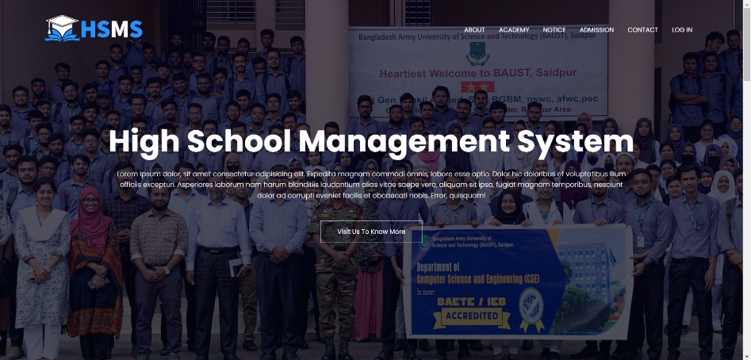.
Figure 3 HSMS Log In Page
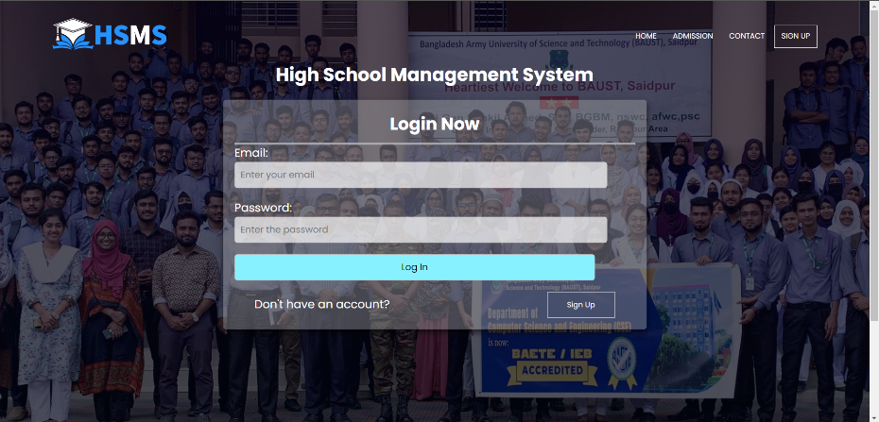

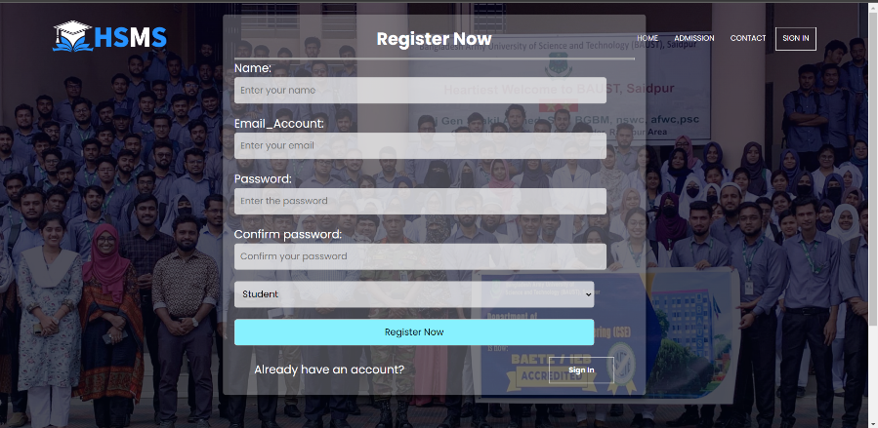
Figure 4 HSMS Registration Page

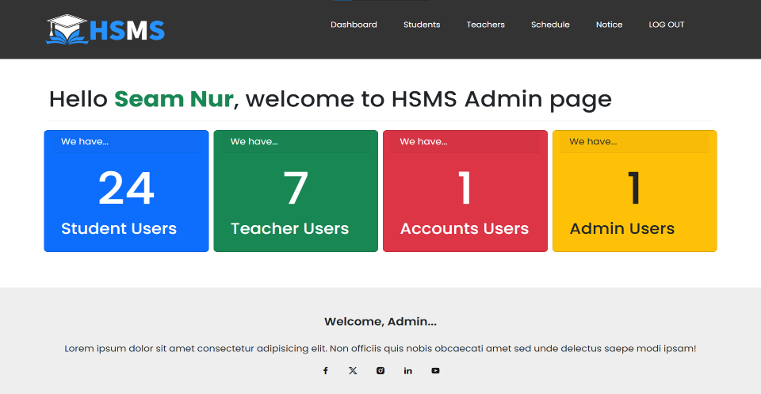
Figure 54 HSMS Admin Home Page
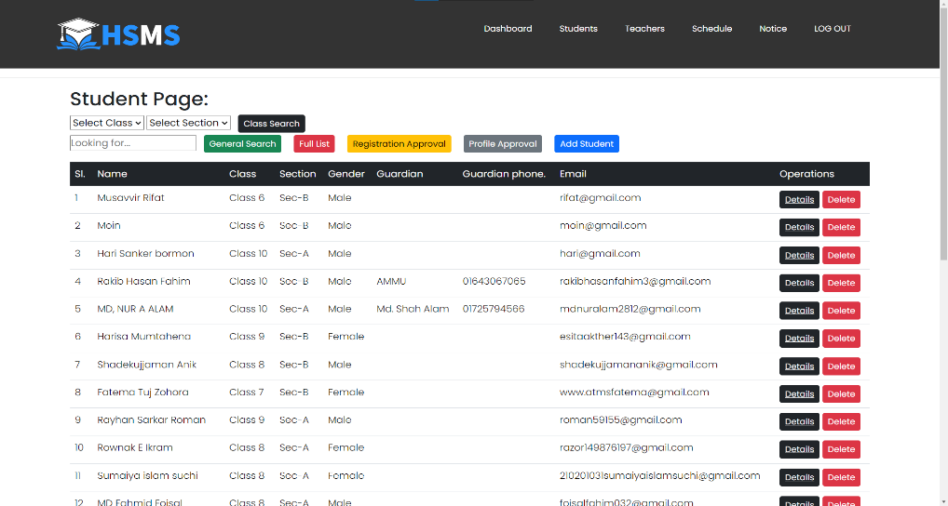
Figure 6 HSMS Admin View Student List

Figure 7 HSMS Admin View Teacher List
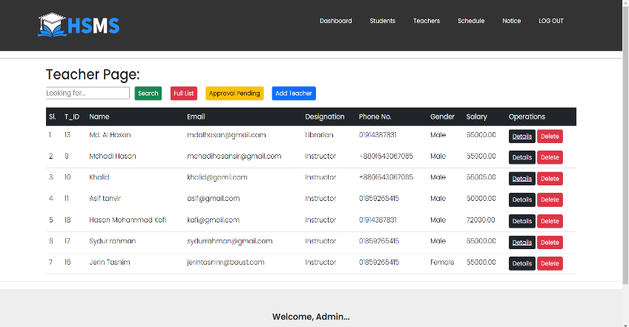

Figure 8 HSMS Admin Routine
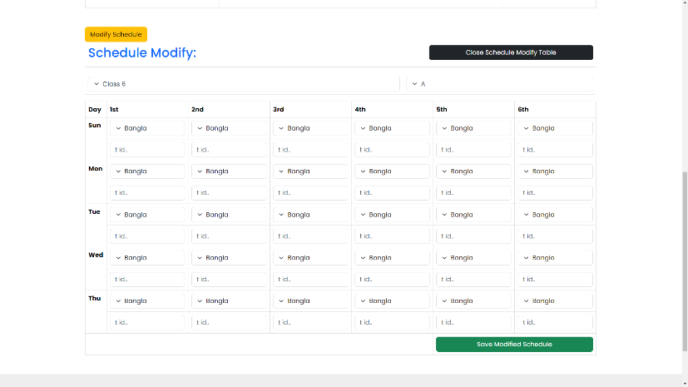

Figure 9 HSMS Admin Set Routine
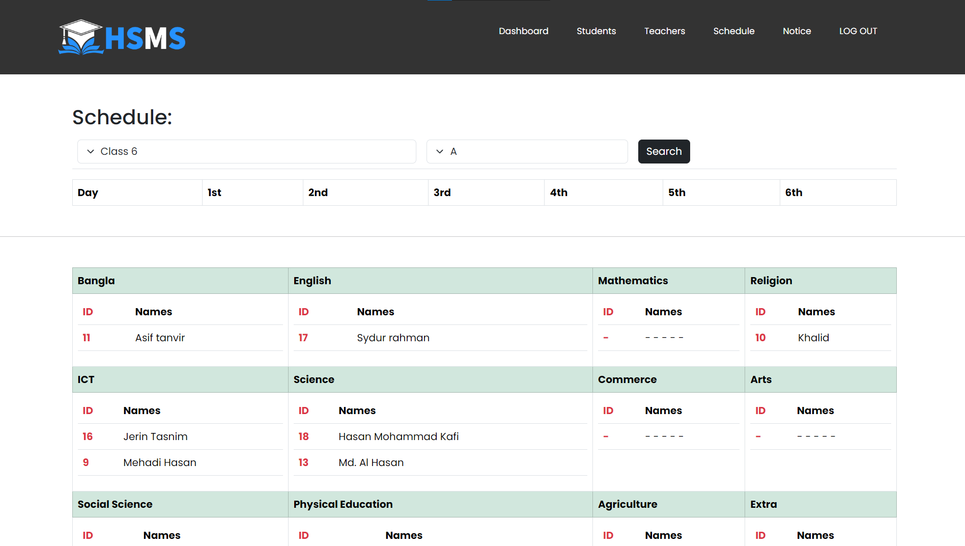
Figure 10 HSMS Teacher Page
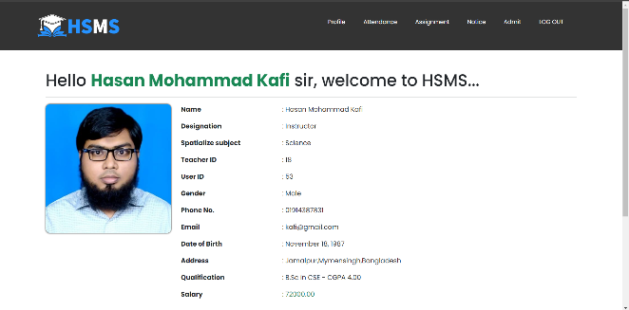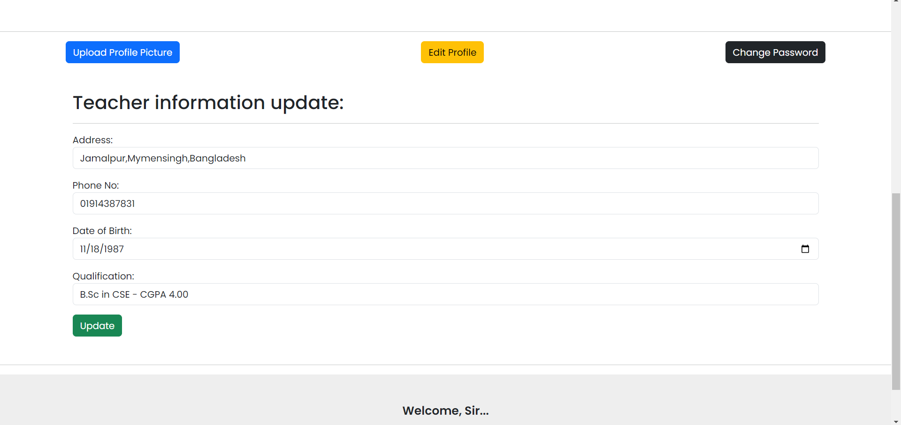
Figure 11 Teacher Take Attendance
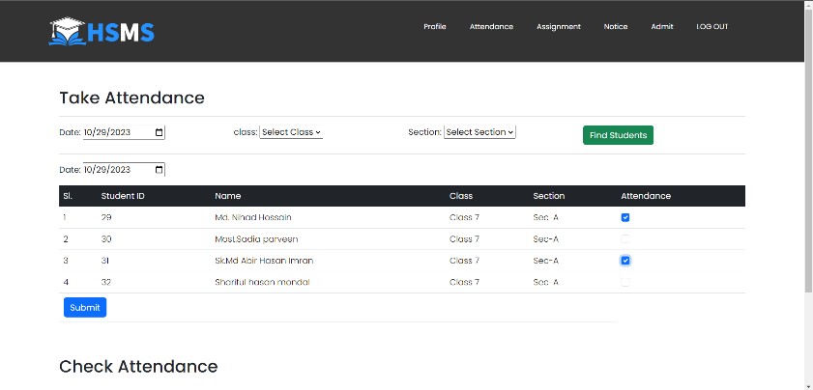
Figure 12 Take Attendance & Notice
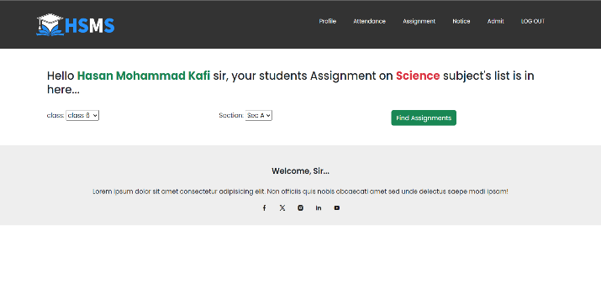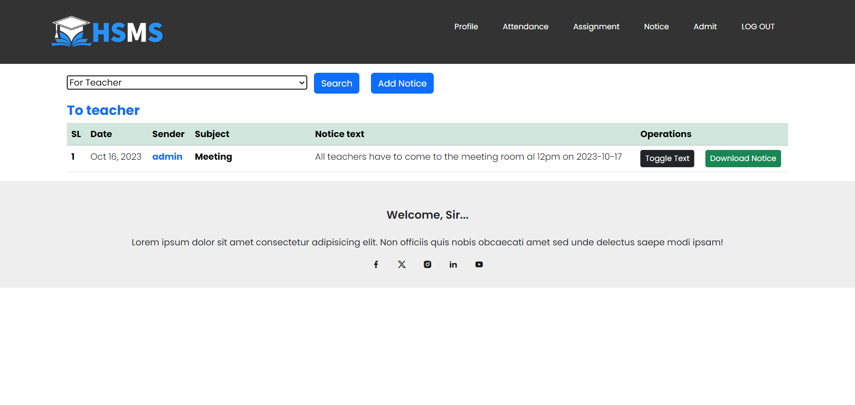

Figure 13 Login As Student
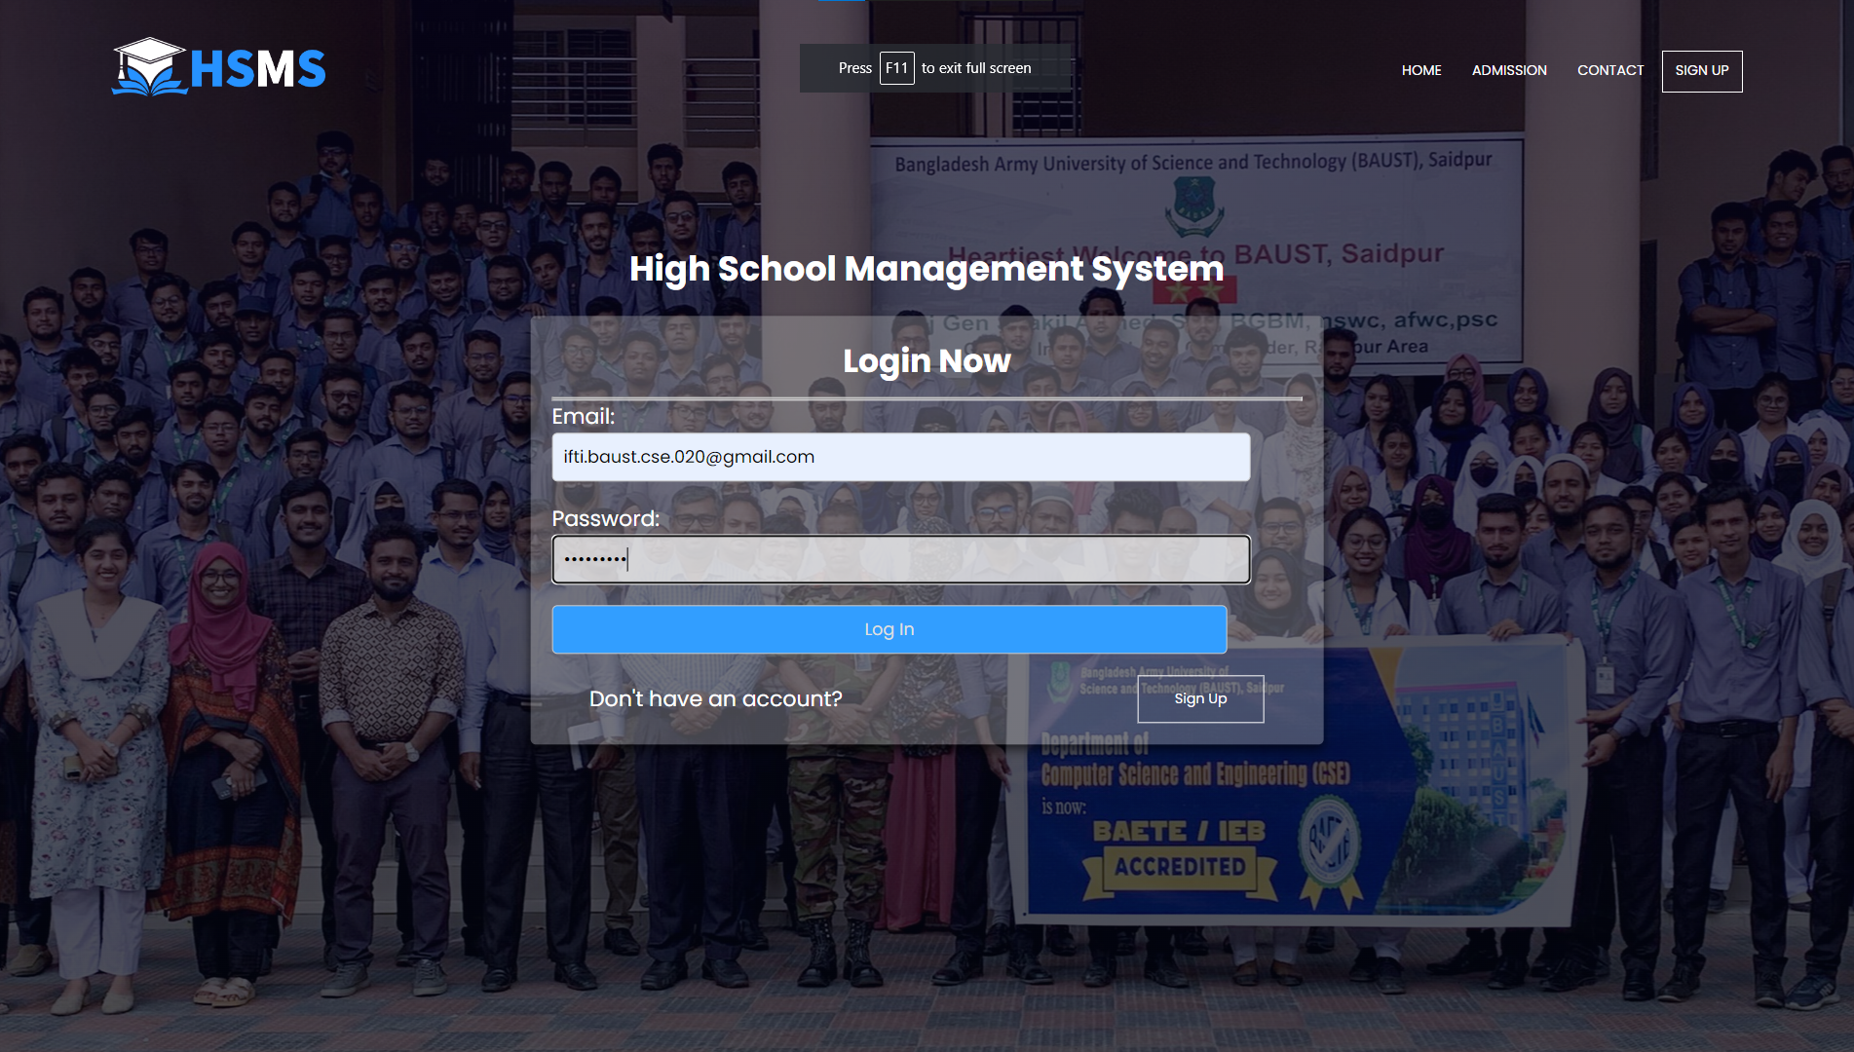
Figure 14 Student HomePage
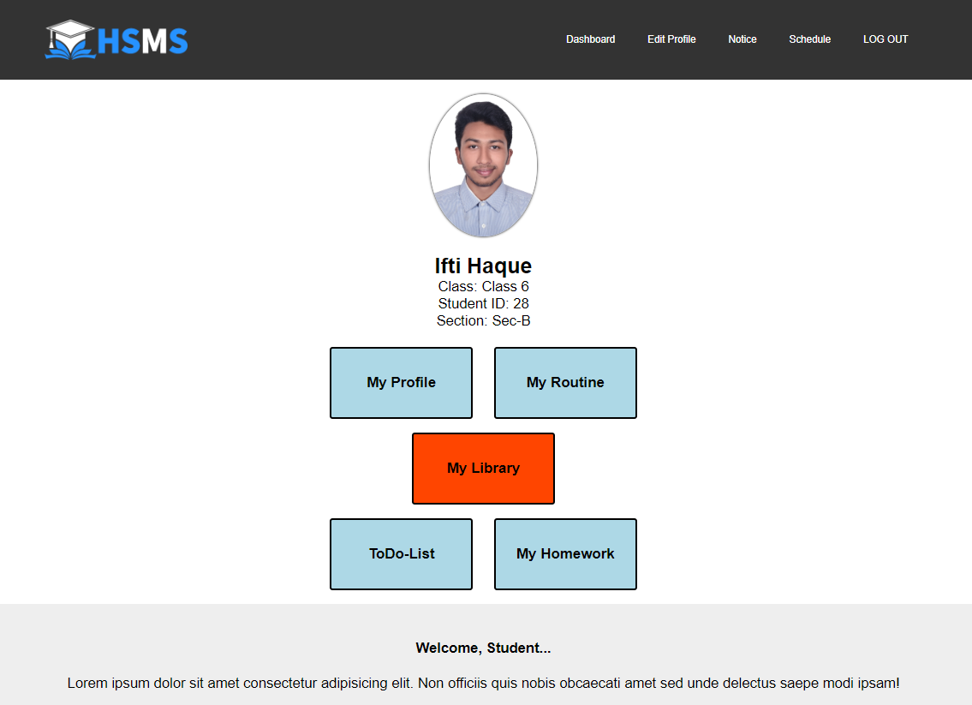

Figure 16 Student Edit Profile
Figure 15 Student Update Password
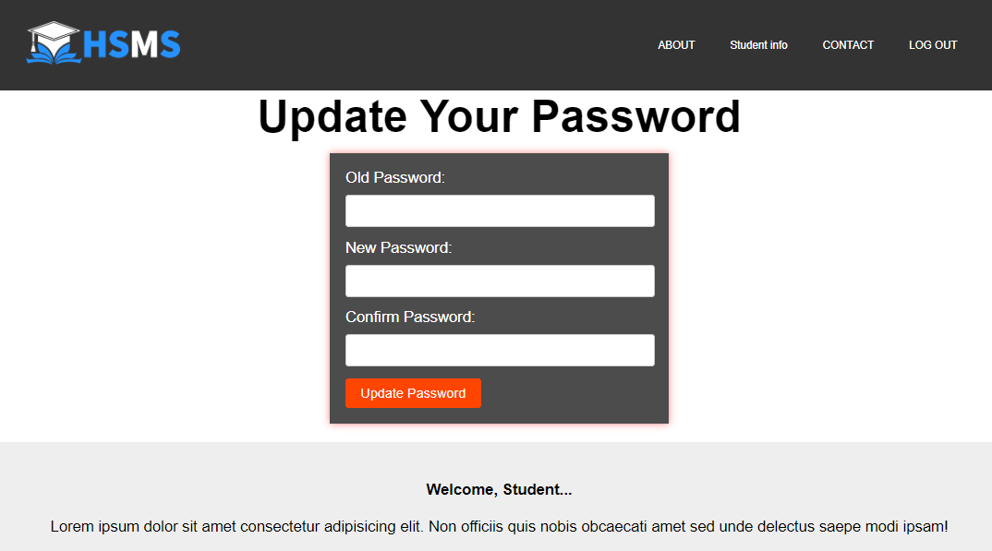
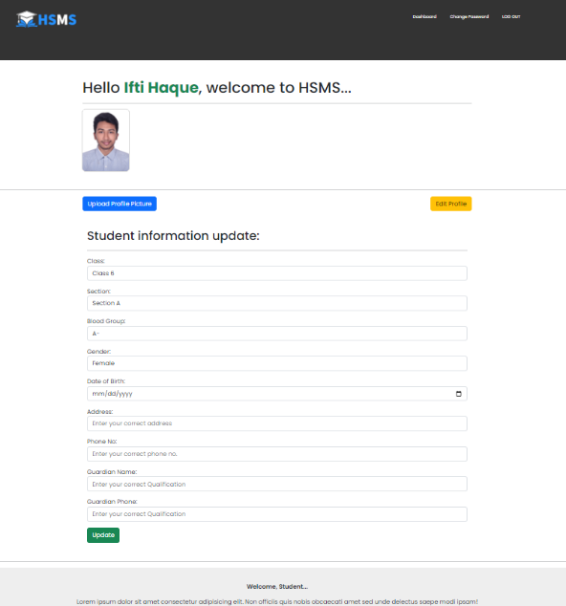
Figure 17 Student View Routine
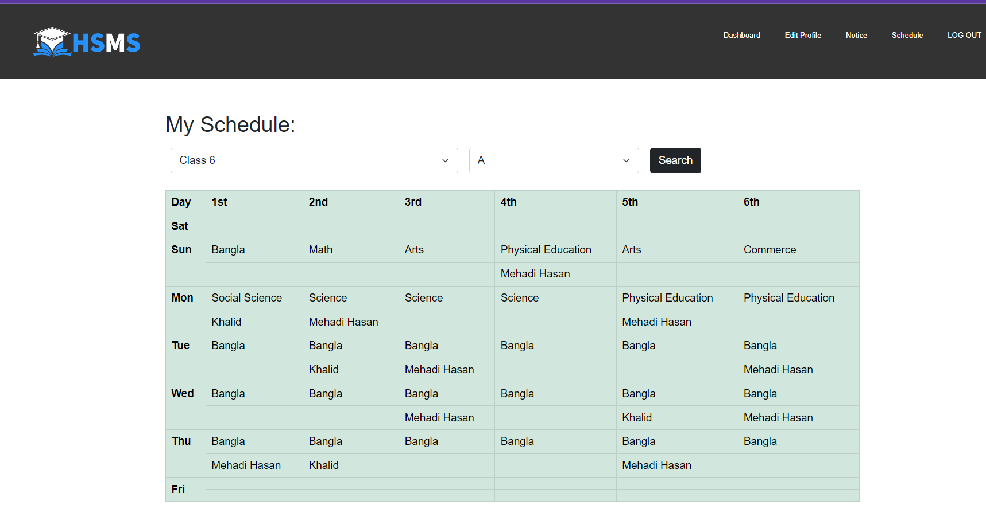

Figure 18 Student Assignment Submission
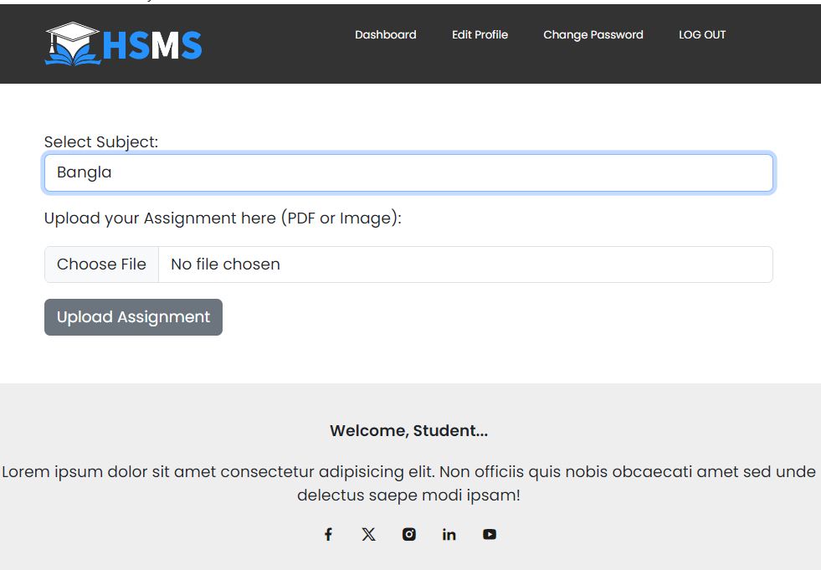
Figure 19 Choose Subject
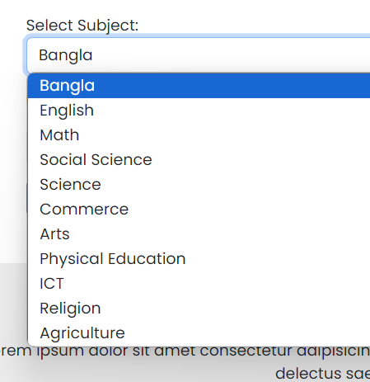

Figure 20 Student View Notice
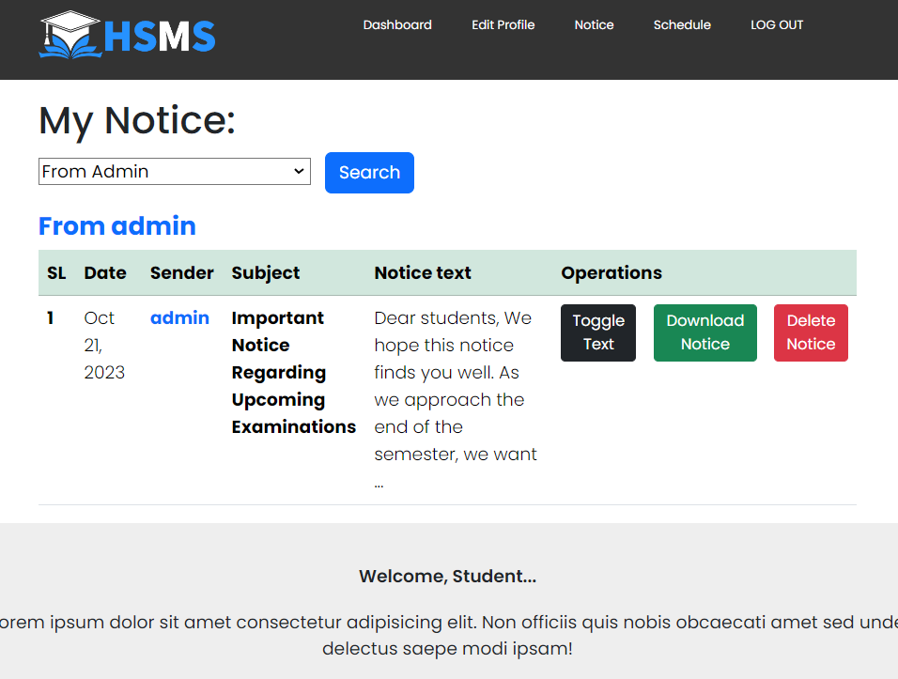
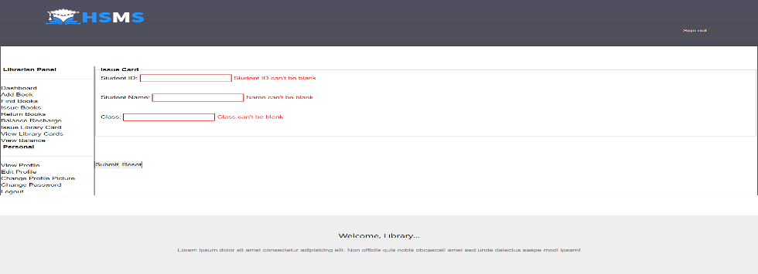
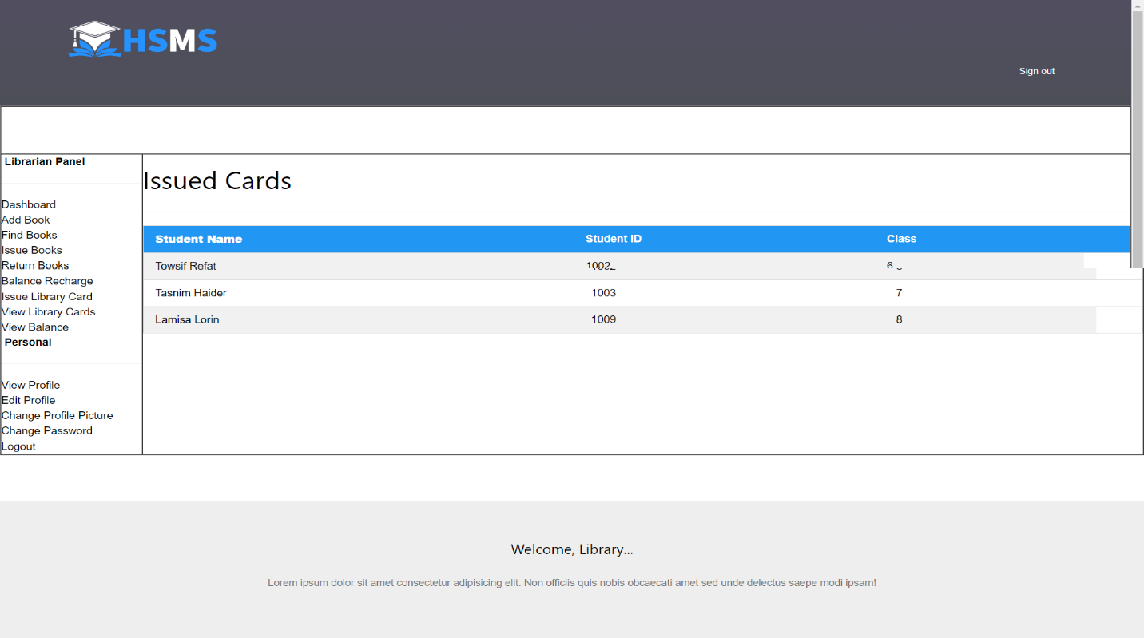
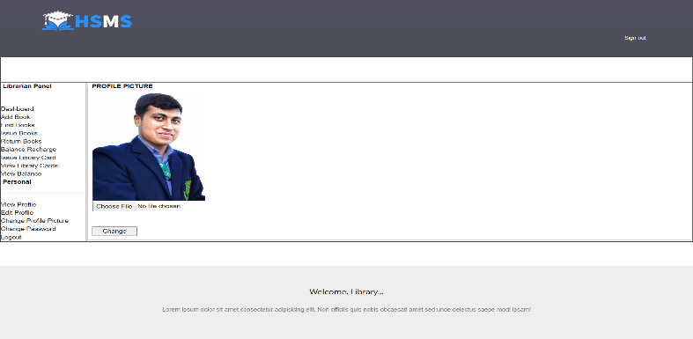
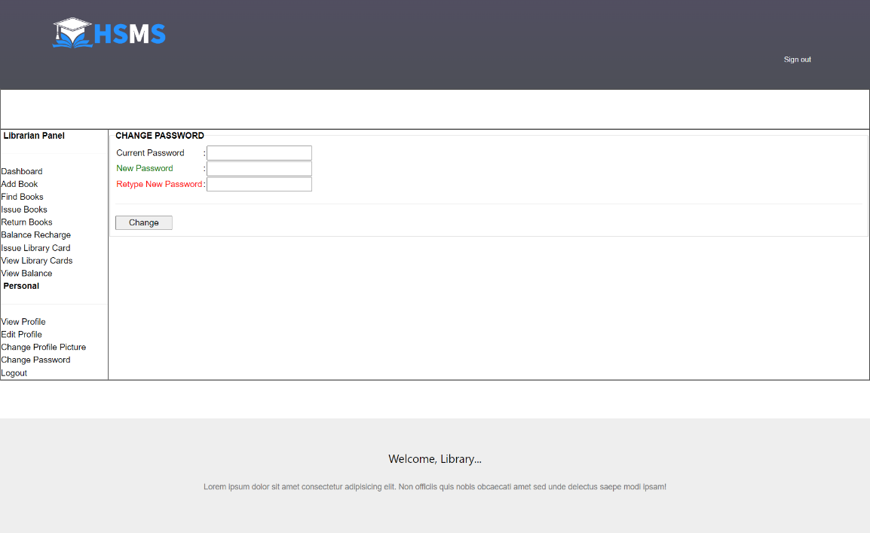
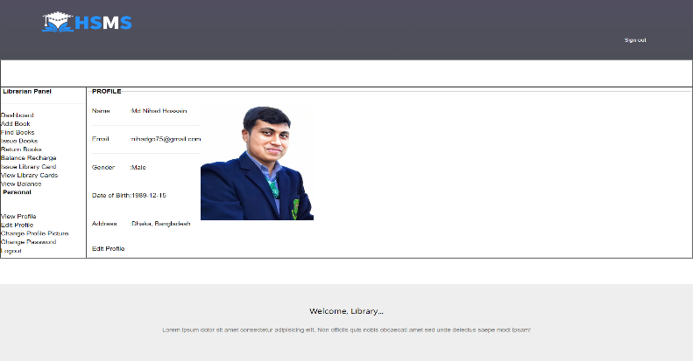
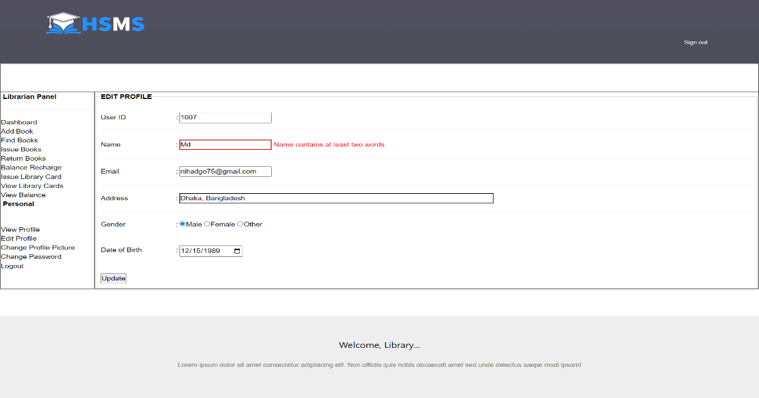
Figure 21 Library Issue Card
Figure 22 Library Profile
Figure 23 Library Profile
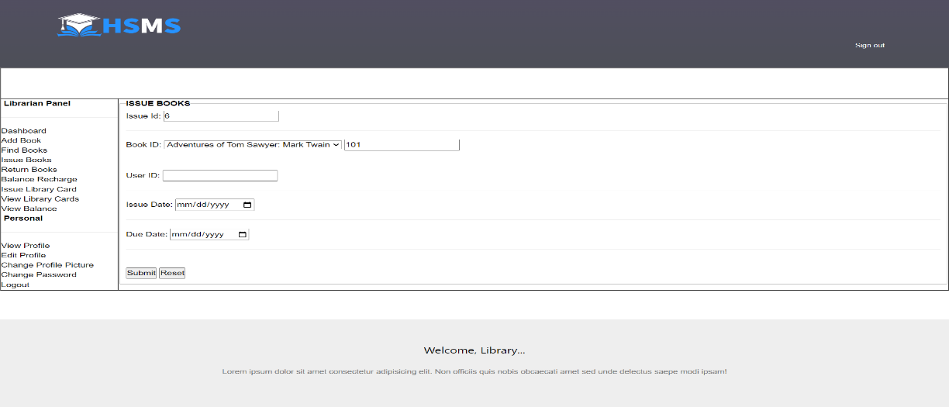
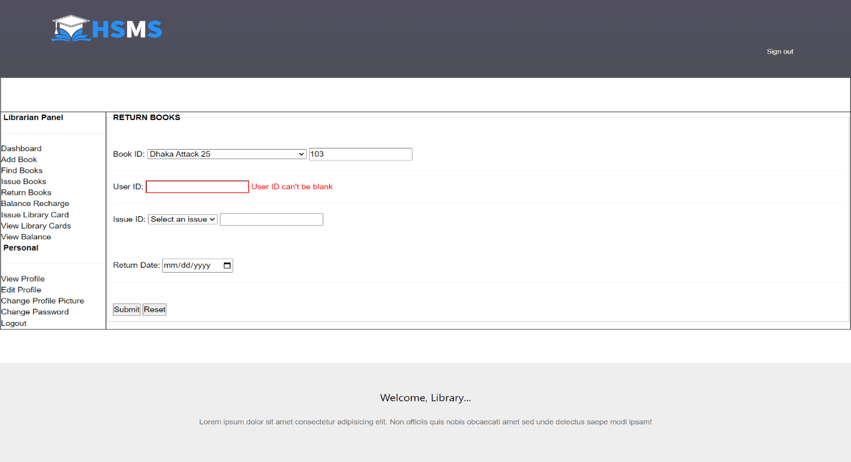
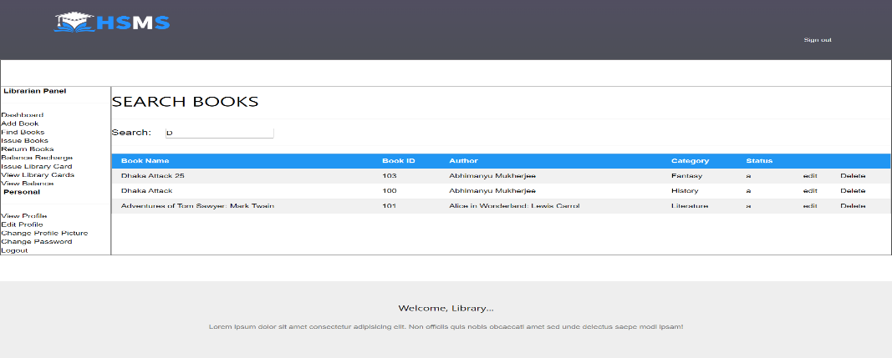
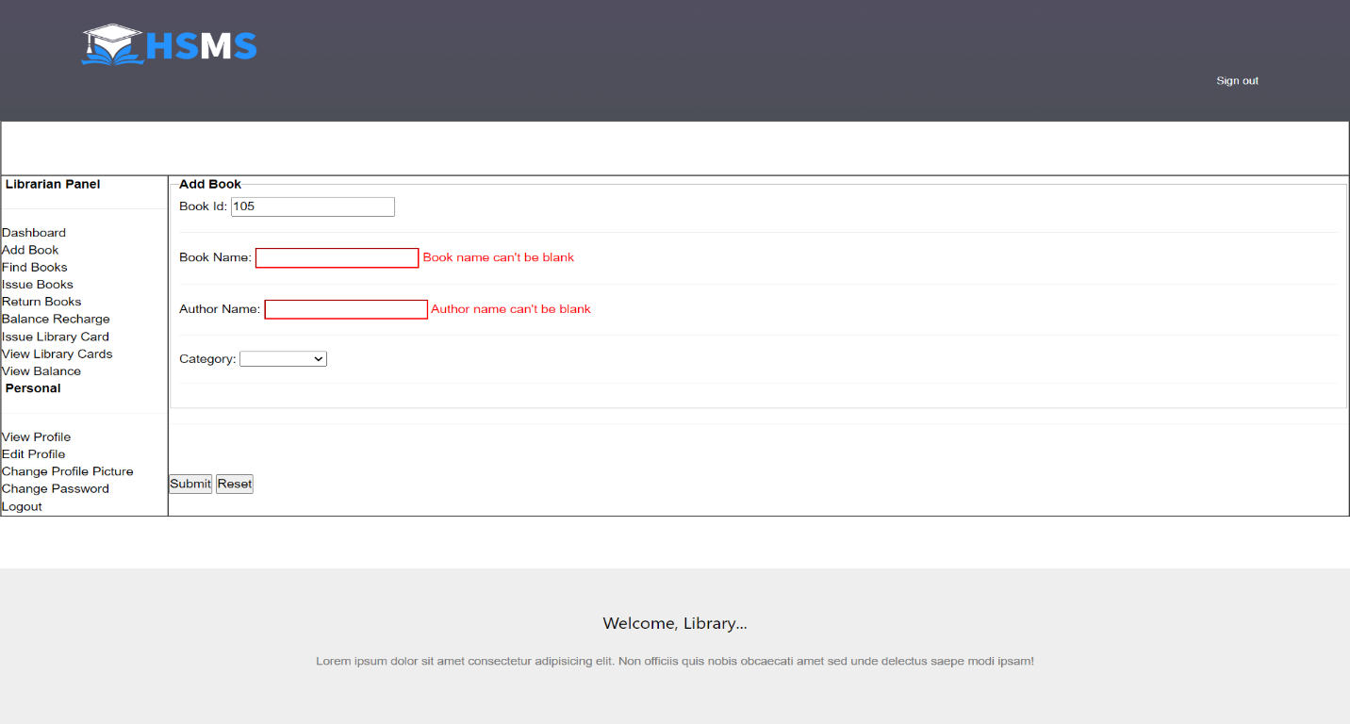
Figure 24 Issue & Return Details
Figure 25 Search Book From Library
Figure 26 Book Borrow History
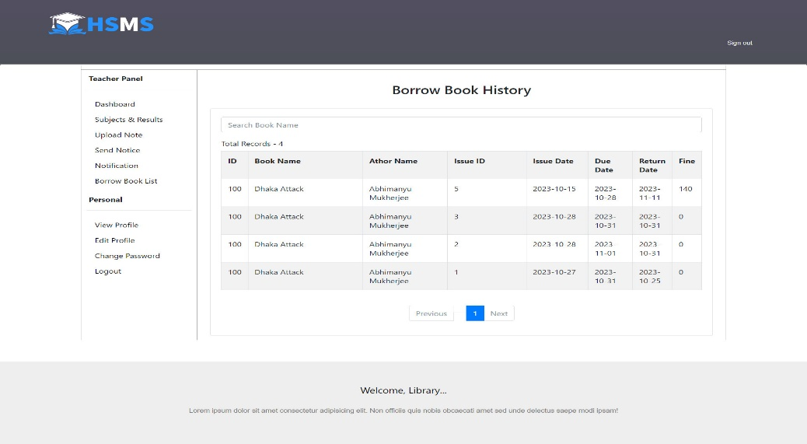

Figure 27 Show Balance
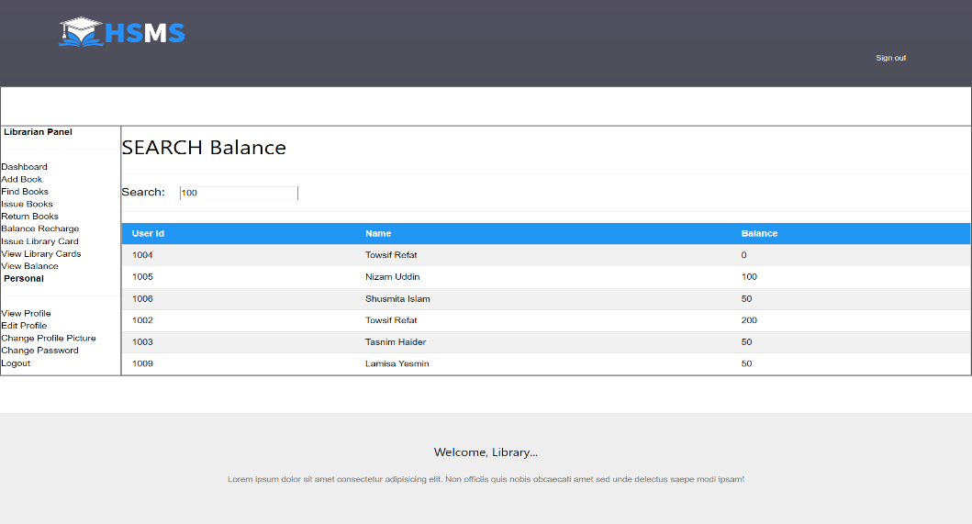

- Conclusion and Limitations
Limitations:
Tuition Fee Payments: The software does not currently support tuition fee payments, limiting its financial management capabilities.
Backup/Logging of Data: There is a lack of built-in features for data backup and logging, potentially posing a risk to data integrity and security.
Exam System Feature: The absence of an exam system feature limits comprehensive academic management within the school management software.

Conclusion:
Our current school management software is functional for academic and administrative needs, but lacks crucial features such as tuition fee payments, data backup/logging, and an exam system, limiting its comprehensive utility. To provide a more complete solution, future developments should consider scalability for larger institutions, increased security measures, and expanded customization options to adapt to various educational models, ensuring a more adaptable and secure software for evolving educational needs.

References
[1] Fekara is an all-in-one school management software that oversees learning, testing, and administrative tasks by handling student, course, exam, teacher, and employee data. https://fekara.com/
[2]Fedena: Simplifies school operations, facilitates informed decisions. https://fedena.com/
[3] SchoolTool: Free student info system for global schools, offering essential features and customization. https://schooltool.neric.org/

Complex Engineering Problems (CP) and Complex Engineering Activities (CA) Analysis

Attainment of Complex Engineering Problem (CP)
S.L. | CP No. | Attainment | Remarks
1. | P1: Depth of Knowledge Required | Yes | K3 (Engineering Fundamentals): Require knowledge of database design (Sec. 7).
 |  |  | K4 (Engineering Specialization): Require Knowledge of Bootstrap (Sec. 8).
 |  |  | K5 (Design): Flow Chart of Methodology shows solution design of the problem (Sec. 6).
 |  |  | K6 (Technology): XAMPP server, PHP, MySQL, Bootstrap, etc. (Sec. 8).
 |  |  | K8 (Research): Studied related application to find limitation (Sec. 3).
2. | P2: Range of Conflicting Requirements | Yes | High School Management System (High School Management Sec. 1), Web technologies (PHP, MySQL, Bootstrap, etc Sec. 8), Database Management System (Sec. 7).
3. | P3: Depth of Analysis Required | No
4. | P4: Familiarity of Issues | Yes | Working with School Educational domain as a CSE student (Sec. 1).
5. | P5: Extent of Applicable Codes | Yes | Use Waterfall software development model (Sec. 6).
6. | P6: Extent of Stakeholder Involvement and Conflicting Requirements | Yes | Involves school administrators, teachers, students, and accountants (Sec. 4)
7. | P7: Interdependence | Yes | Involve login, attendance, notice, assignment, library, todo-list, etc (Sec. 9).

Mapping of Complex Engineering Activities (CA)
S.L. | CA No. | Attainment | Remarks
1. | A1: Range of resources | Yes | Involves school administrators, teachers, students, and accountants, Technologies: PHP, MySQL, MVC, Bootstrap, Laravel, etc. (Sec. 4 and Sec. 8).
2. | A2: Level of interaction | Yes | Solve problem arises from various conflicting and other issues (Sec. 5).
3. | A3: Innovation | No
4. | A4: Consequences for Society and the Environment | Yes | Provides knowledge, tools and technologies for overall school maintenance which will increase productivity and profitability (Sec. 10).
5. | A5: Familiarity | No

